New: HIT V ALPIN
innovative and efficient alpine tedders

The Austrian agricultural machinery manufacturer Pöttinger knows that steep and bumpy terrain is particularly challenging. This is exactly what the new Alpin machines were designed for. The whole range of alpine harvesting equipment has been updated over the past few years. Joining the NOVACAT F ALPIN mower, MERGENTO F ALPIN merger and BOSS ALPIN loader wagon, the HIT V ALPIN tedder now closes the loop in making alpine hay harvesting more efficient and sustainable.
Regardless of whether tedding silage or hay, the HIT V 4240 ALPIN with 4 rotors and the HIT V 6260 with 6 rotors enable uniform and gentle wilting and drying of the crop. This is especially important for high-quality forage that preserves all the nutrients.

Outstanding technology for a neat spread pattern
The beating heart of every HIT V ALPIN tedder is the weight-optimised DYNATECH rotor unit. Thanks to the dynamic, sweeping shape of the tine arms, the tines are pulled through the crop. This minimises disintegration losses and conserves the forage as it is lifted from the ground. The tines are of different lengths to ensure neat work. With a diameter of just 1.38 m, the rotors adapt perfectly to the ground and leave a tidy spread pattern.

Best ground tracking for clean forage
An optional MULTITAST jockey wheel on the pivoting headstock tracks the ground just ahead of the tine path and reacts to each undulation. This makes sure that there is always the same gap between the tines and the ground to keep the forage clean and conserve the sward.

Ready for steep slopes at the highest level
In the working position and at headlands, the compact design of the headstock on the HIT V 4240 ALPIN and HIT V 6260 ALPIN ensures that the centre of gravity is always close to the tractor. This is ideal when operating on steep terrain. Two hydraulic centring cylinders keep the machine running smoothly without overrunning, even when driving downhill. When the machine is lifted at the headland, it moves gently into the central position. These tedders are equipped with a mechanical fenceline tedding system as standard. The HIT V 6260 ALPIN is also equipped with HYDROLIFT to provide even higher ground clearance at the headland. This lifts the outer pairs of rotors into a limit position when the spool valve is briefly actuated. Thanks to the rigid headstock on the HIT V 4240 L ALPIN, it offers additional stability on extremely steep slopes.

Durable and easy to use
The drive train on HIT V ALPIN tedders is equipped with sealed constant velocity joints. These ensure consistent, smooth, backlash free drive to the rotors. No backlash can accumulate from the innermost to the outermost rotor.
A compact transport position with the rotors folded upwards hydraulically makes it convenient to operate from the tractor seat. The raised rotors are tilted in close to the tractor. This ensures an optimum centre of gravity during transport.

Featuring innovative functions and a robust design, HIT V ALPIN tedders offer the perfect combination of efficiency, durability and adaptability. These machines are reliable team players in alpine regions.

Photo preview:

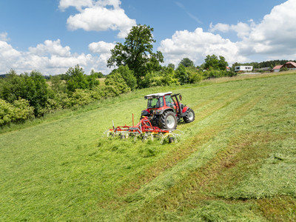 | 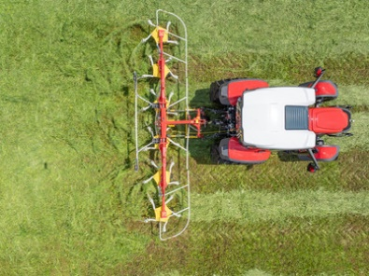
The HIT V 6260 ALPIN tedder does a brilliant job on steep terrain | HIT V 6260 ALPIN tedders accept every challenge
https://www.poettinger.at/de_at/newsroom/pressebild/135621 | https://www.poettinger.at/de_at/newsroom/pressebild/135628

More printer-optimised photos: www.poettinger.at/presse

